EX No:1b | EDA DATA CLEANING

AIM

To perform exploratory data analysis on the Hotel Booking Demand dataset by examining the dataset structure, dimensions, data types, statistical characteristics, missing values, hotel-wise and customer-wise booking distributions, cancellation patterns, correlations among numerical attributes, and exporting the dataset into different file formats.

ALGORITHM
- Import the required libraries such as kagglehub, os, and pandas.
- Download the Hotel Booking Demand dataset using KaggleHub.
- Identify the CSV file available in the downloaded dataset.
- Load the CSV file into a Pandas DataFrame using latin1 encoding.
- Display the first five and last five records.
- Display the dataset information, shape, column names, and data types.
- Generate descriptive statistical information for numerical attributes.
- Identify the number of missing values in each column.
- Find the top 10 countries based on the number of hotel bookings.
- Analyze the distribution of bookings across different hotel types.
- Analyze the distribution of booking cancellations.
- Display the unique customer types available in the dataset.
- Generate the correlation matrix for numerical attributes.
- Export the dataset into CSV, Excel, and JSON formats.
- Display a confirmation message after successful file creation.

CODE
import kagglehub

# Download latest version
path = kagglehub.dataset_download("jessemostipak/hotel-booking-demand")

print("Path to dataset files:", path)

import os
import pandas as pd

print("Dataset path:", path)

print("\nFiles in dataset:")

print(os.listdir(path))

# Find CSV file automatically
csv_file = [f for f in os.listdir(path) if f.endswith(".csv")][0]

print("\nCSV file:", csv_file)

# Load dataset
df = pd.read_csv(
os.path.join(path, csv_file)
)

print("\nFirst 5 rows:")

display(df.head())

print("\nLast 5 rows:")

display(df.tail())

print("\nDataset information:")

df.info()

print("\nShape:")

print(df.shape)

print("\nColumns:")

print(df.columns.tolist())

print("\nData types:")

print(df.dtypes)

print("\nStatistical description:")

display(df.describe())

print("\nMissing values:")

display(df.isnull().sum())

print("\nTop 10 countries:")

display(df["country"].value_counts().head(10))

print("\nHotel types:")

display(df["hotel"].value_counts())

print("\nCancellation distribution:")

display(df["is_canceled"].value_counts())

print("\nCustomer types:")

display(df["customer_type"].value_counts())

print("\nUnique customer types:")

print(df["customer_type"].unique())

print("\nCorrelation:")

display(df.corr(numeric_only=True))

# Excel
df.to_excel("hotel_booking_data.xlsx", index=False)

# JSON
df.to_json("hotel_booking_data.json", orient="records", indent=4)

# CSV
df.to_csv("hotel_booking_data.csv", index=False)

print("\nCSV, Excel and JSON files created successfully.")

OUTPUT

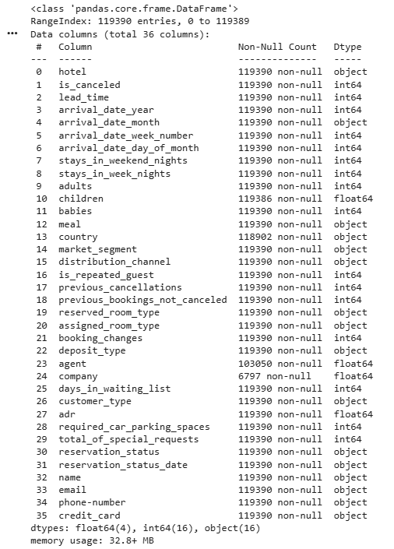
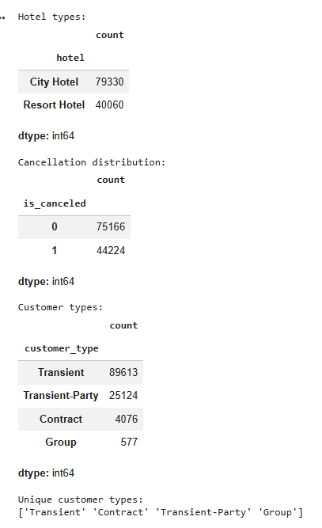
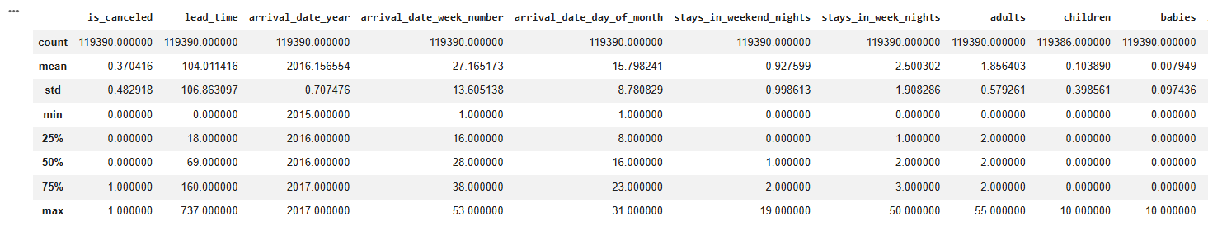
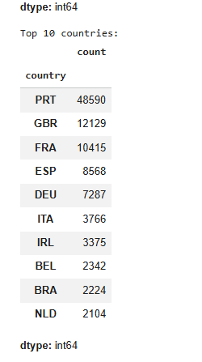

RESULT

